# Features of Java

The prime reason behind creation of Java was to bring portability and security feature into a computer language. Beside these two major features, there were many other features that played an important role in molding out the final form of this outstanding language.

## Simple

JAVA is simple because of the following factors:

1. JAVA is free from pointers hence we can achieve less development time and less execution time [whenever we write a JAVA program we write without pointers and internally it is converted into the equivalent pointer program].
2. Rich set of APIs (application protocol interface) is available to develop any complex application.
3. The software JAVA contains a program called garbage collector which is always used to collect unreferenced (unused) memory location for improving performance of a JAVA program. [Garbage collector is the system JAVA program which runs in the background along with regular JAVA program to collect unreferenced memory locations by running at periodical interval of times for improving performance of JAVA applications.
4. JAVA contains user friendly syntax’s for developing JAVA applications.

# Platform Independent

A program or technology is said to be platform independent if and only if which can run on all available operating systems. Unlike many other programming languages including C and C++, when Java is compiled, it is not compiled into platform specific machine, rather into platform independent byte code. This byte code is distributed over the web and interpreted by virtual Machine(JVM)on whichever platform it is being run. On compilation Java program is compiled into bytecode. This bytecode is platform independent and can be run on any machine, plus this bytecode format also provide security.

Any machine with Java Runtime Environment can run Java Programs. The languages like C, Cpp are treated as platform dependent languages since these languages are taking various amount of memory spaces on various operating systems [the operating system dos understands everything in the form of its native format called Mozart(MZ) whereas the operating system

Unix understands everything in its negative format called embedded linking format (elf). When we write a C or Cpp program on dos operating and if we try to transfer that program to Unix operating system, we are unable to execute since the format of these operating systems are different and more over the C, Cpp software does not contain any special programs which converts one format of one operating system to another format of other operating system].

The language like JAVA will have a common data types and the common memory spaces on all operating systems and the JAVA software contains the special programs which converts the format of one operating system to another format of other operating system. Hence JAVA language is treated as platform independent language. [JAVA language is also treated as server independent language since the server-side program can run on any of the server which is available in the real world (web server or application server).

JAVA can retrieve or store the data in any one of the data base product which is available in rest world irrespective of their vendors (developers) hence JAVA language is product independent language. In order to deal with server-side program from the client side, we can use C language client program, Cpp client program, DOT NET client program, etc. hence JAVA language is a simple, platform independent, server independent, data base/product independent and language independent programming language].

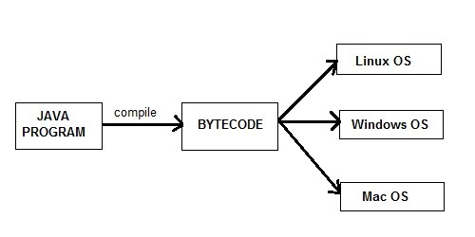

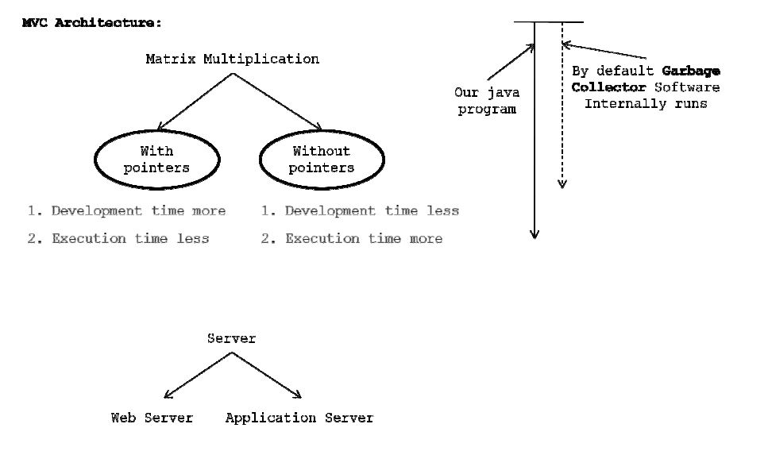

# Architectural Neutral

Java compiler generates an architecture-neutral object file format, which makes the compiled code to be executable on many processors, with the presence of Java runtime system.

A language or technology is said to be processors in the real world. The language like JAVA can run on any of the processor irrespective of their vendor.

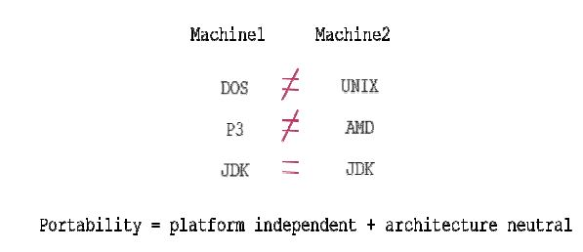

**Figure: Platform Independent**

# Portable

A portable language is one which can run on all operating systems and on all processors irrespective their architectures and providers. The language like C, Cpp are treated as nonportable languages whereas the language Java is called portable language

# Multi-Threading

With Java’s multithreaded feature, it is possible to write programs that can do many tasks simultaneously. This design feature allows developers to construct smoothly running interactive applications. Benefit of multithreading is that it utilizes same memory and other resources to execute multiple threads at the same time, like While typing, grammatical errors are checked along.

1. A flow of control is known as thread.
2. A multi-threaded program is one in which there exist multiple flow of controls i.e. threads.
3. A program is said to be multi-threaded program programs if and only of there exist n number of subprograms. For each and every sub flow of controls. All such flow of controls is executing concurrently. such flow of controls is known as threads. Such type of applications is known as multi-threading applications.
4. The languages like C, Cpp are treated as threads as single threaded modeling languages(STML). STML are those in which there exists single flows of control.
5. The languages like JAVA and DOT NET are treated as multithreaded modeling languages(MTML). MTML are those in which there exist multiple flows of controls.
6. Whenever we write a java program there exists by default two threads. They are foreground/child thread and background/main/parent thread.
7. A foreground thread is one which always executes user defined sub program. In a java program there is a possibility of existing n number of foregrounds threads.
8. A background thread is one which always monitors the status of foreground thread. In each and every JAVA program there exist only one background thread.
9. Hence background thread will be created first and later foreground thread will be created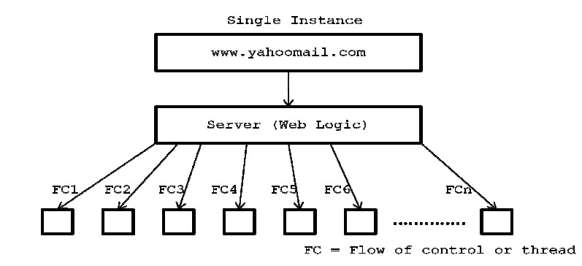

# Distributed

Java is designed for the distributed environment of the internet. A service is a said to be a distributed service which runs in multiple servers and that service can be accessed by n number of clients across the globe. In order to develop we must require architecture called trusted network architecture. To develop these applications, we require a technology called J2EE. A service is a said to be a can be accessed by n number of clients across the globe. In order to develop applications, we must require architecture called applications we require a technology called scale organizations.

J2SE (Core JAVA) Notes is known as thread. multi-threaded program is one in which there exists multiple flow of controls multi-threaded program if and only of there exists n number of sub programs. For each and every sub-program there exists a separate flow of control are executing concurrently. Such flow of controls is known as type of applications is known as multi-threading applications.

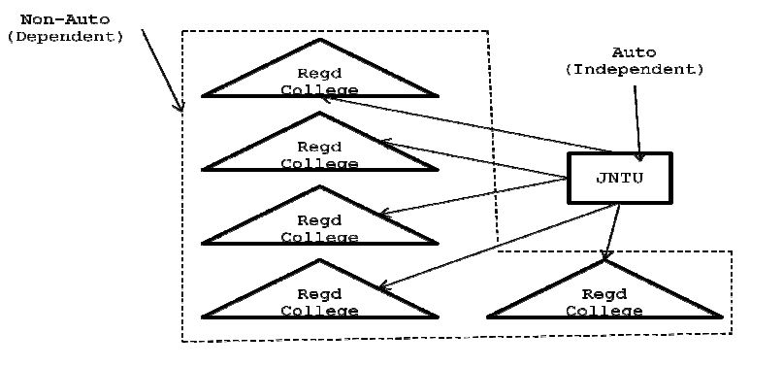

# Networked

In real world we have two types of networks. They are untrusted and trusted networks.

1. Un-trusted networks: A network is said to be untrusted network in which there exist n number of inter connected non-autonomous architecture. Untrusted network is also known as LAN. Using this network architecture, we develop centralized applications. A Centralized application is one which runs on single server and runs on single server and it can be access in limited graces. In order to develop centralized application, we may use a technology called J2Se and these kinds of applications are preferred by small scale organization.
2. Trusted network: A network is said to be trusted network in which there exist n number of interconnected autonomous architecture. Trusted network is also known as a WAN. Using this network, we can develop distributed applications. and it can be access in unlimited graces. In order to develop distributed applications, we may use a technology called J2EE and these kinds of applications are preferred by large scale organization.

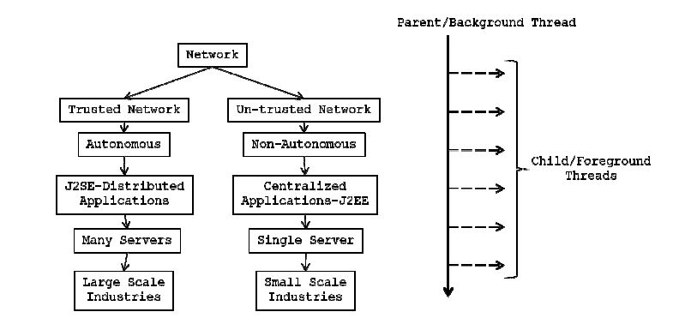

# Dynamic

Java is considered to be more dynamic than C or C++ since it is designed to adapt to an evolving environment. Java programs can carry extensive amount of run-time information that can be used to verify and resolve accesses to objects on run-time.

# Portable

Being architectural-neutral and having no implementation dependent aspects of the specification makes Java portable. Compiler in Java is written in ANSI C with a clean portability boundary which is a POSIX subset.

# High Performance

With the use of Just-In-Time compilers, Java enables high performance.

# Interpreted

Java byte code is translated on the fly to native machine instructions and is not stored anywhere. The development process is more rapid and analytical since the linking is an incremental and lightweight process.

# Secure

With Java’s secure feature, it enables to develop virus-free, tamper-free systems. Authentication techniques are based on public-key encryption.

# Object Oriented

In Java, everything is an Object. Java can be easily extended since it is based on the Object model.

# Robust

Java makes an effort to eliminate error prone situations by emphasizing mainly on compile time error checking and runtime checking. Java makes an effort to eliminate error prone codes by emphasizing mainly on compile time error checking and runtime checking. But the main areas which Java improved were Memory Management and mishandled Exceptions by introducing automatic Garbage Collector and Exception Handling.